

**Project Title:**

**[LUDO DICE]**

Submitted by:

**[Zain Choudhary]       [223323]**

**[Bilal Irfan]       [223321]**

**[Muhammad Sami]       [223373]**

Submitted to:

**[Sir Irfan]**

Course:

**[Computer Logic Design]**

Semester:

**[2nd Semester]**

Date of Submission:

**[03-08-2023]**



**IN THE NAME OF ALLAH THE MOST BENEFICENT**

**THE MOST MERCIFUL**

**Abstract**

The Ludo Dice Breadboard Project aims to create a digital dice using a breadboard circuit to simulate the rolling of a dice in the popular board game Ludo. This project utilizes various electronic components to generate random numbers, emulating the rolling of a traditional dice. The digital dice offers a convenient and reliable solution, eliminating the need for physical dice and ensuring fair gameplay.

The Ludo Dice Roll Simulation project serves as an educational tool for learning and practicing Computer Logic Design concepts. It offers insights into binary representation, state machines, sequential logic, and randomness generation within the context of a classic board game. The project encourages hands-on experimentation, troubleshooting, and optimization, fostering a deeper understanding of digital circuitry and logic manipulation.

By successfully implementing the Ludo Dice Roll Simulation using Computer Logic Design techniques, this project demonstrates the practical application of theoretical concepts in a tangible and engaging manner. It showcases the ability to transform abstract notions of logic into functional hardware, enhancing the learning experience for individuals studying digital electronics and logic design.

**Table Of Contents**

1. **Introduction**
   1. **Problem Definition**

Randomness Generation

Binary Representation

Sequential Logic

Output Visualization

Testing and Validation

Optimization

Educational Value

1. **Methodology and Implementation\**

Requirement Analysis

Sequential Logic Design

**Chapter 1**

**Introduction**

The traditional game of Ludo involves rolling a dice to determine the number of moves a player can make. This project aims to replace the physical dice with a digital alternative, improving convenience and accuracy. By implementing a breadboard circuit, we can create a compact and portable device that generates random numbers, replicating the functionality of a traditional dice.

The project's design process encompasses a comprehensive understanding of binary encoding for dice faces, the utilization of flip-flops to establish sequential states, and the integration of logic gates to generate unbiased and unpredictable dice values. Beyond the core logic implementation, an integral facet of the project involves devising a visual output mechanism to convey the rolled dice value effectively to the user.

The Ludo Dice Roll Simulation not only serves as a captivating application of CLD but also holds pedagogical value. It serves as a platform for enthusiasts and learners to bridge the gap between theory and practice. As the project unfolds, participants engage in hands-on exploration, honing their skills in circuit design, debugging, and optimization. This practical exposure fosters a deeper comprehension of digital logic principles that extend beyond the confines of textbooks and into real-world scenarios.

* 1. **Problem statement**

The traditional method of rolling a physical dice in Ludo can be cumbersome and prone to errors. Players often encounter issues such as dice rolling off the board, biased results, or disputes regarding the outcome. The Ludo Dice Breadboard Project addresses these problems by providing a reliable and efficient digital dice solution.

The core problem statements that this project aims to tackle include:

**Randomness Generation:**

Designing a digital circuit that generates random sequences, effectively emulating the unpredictability of rolling a physical dice. Ensuring that the generated values exhibit a balanced distribution and are unbiased is crucial to maintaining fairness in the simulation. **Binary Representation:**

Developing a mechanism to represent the faces of a dice in binary format. Each face of the dice must be uniquely encoded to enable sequential logic and accurate state transitions within the circuit. **Sequential Logic:**

Creating a state machine that captures the progression of dice rolls. This entails utilizing flip-flops and counters to manage the sequence of outcomes, ensuring that each roll is distinct and unrelated to the previous one.

**Output Visualization:**

Implementing an output display mechanism that conveys the rolled dice value in a user-friendly manner. The challenge is to present the result using LEDs, a seven-segment display, or a suitable alternative, enhancing the overall gaming experience.

**Testing and Validation:**

Ensuring the reliability and correctness of the circuit through comprehensive testing. This involves verifying that the generated values adhere to statistical randomness properties and that the circuit functions as intended under various scenarios.

**Optimization:**

Exploring opportunities to optimize the circuit for efficiency and resource utilization. This includes minimizing component count, reducing power consumption, and enhancing the speed of dice value generation.

**Educational Value:**

Demonstrating the educational significance of the project by providing a platform for learners to apply CLD concepts in a practical setting. The project should facilitate a deeper understanding of binary representation, state machines, and logic gate manipulation.

By addressing these problem statements, the Ludo Dice Roll Simulation project aims to showcase the power of Computer Logic Design in creating a captivating and authentic electronic version of the dice rolling mechanism in the beloved game of Ludo.

**Chapter 2**

**Methodology and Implementation**

The methodology for the Ludo Dice Roll Simulation project involves a step-by-step approach to designing and implementing the digital circuit that emulates the randomness of dice rolling. Here's how the project's methodology aligns with its practical implementation:

**Requirement Analysis:**

Understand the requirements for the project, including the need for randomness, binary representation, sequential logic, and visual output. Binary Encoding: Design a binary encoding scheme to represent each dice face uniquely, using a sufficient number of bits to accommodate all possible outcomes.

**Sequential Logic Design:**

Develop a state machine that progresses through states corresponding to each possible dice outcome. Use flip-flops and counters to manage the state transitions, ensuring each roll is independent of the previous one.

**Randomness Generation:**

Implement logic circuits that generate random sequences, combining elements of combinatorial and sequential logic. Apply techniques like feedback shift registers or linear feedback shift registers to achieve randomness.

**Output Display:**

Choose a display method like LEDs or a seven-segment display to visualize the rolled dice value. Design logic circuits to convert the binary dice representation into the appropriate display output.

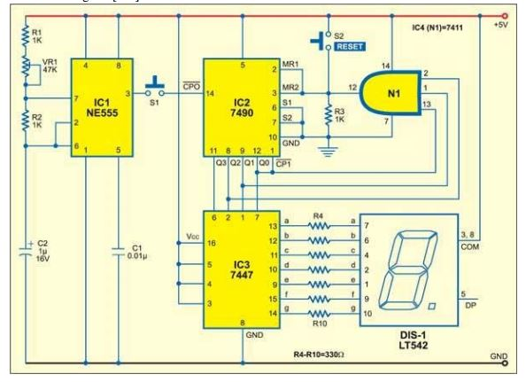**Circuit Diagram**

**Block Diagram**

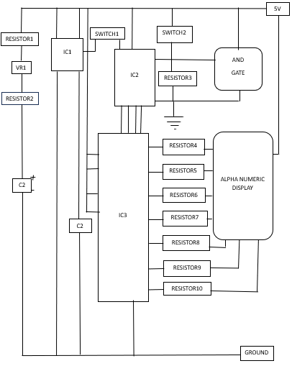

**Expected Output and post analysis**

The expected output of the system is a random number displayed on the LED, simulating the roll of a dice. Post analysis of the system involves testing the accuracy and randomness of the generated numbers. Statistical analysis can be performed to ensure fair gameplay, eliminating any bias or predictability in the results.

**Applications and Advantages**

The proposed Ludo Dice Breadboard Project offers several advantages over traditional dice rolling methods. It provides a reliable and fair gameplay experience by eliminating biased outcomes and disputes. The digital dice is portable and can be easily integrated into existing Ludo game boards. Additionally, the project introduces an educational aspect by involving electronic components promoting STEM learning.

**COST ANALYSIS**

THINGS Which Are REQUIRED INCLUDES:

1. Three Resistors (1K Ohm) 20Rs max

2. IC1 NE555 100Rs max

3. IC2 7490 100Rs max

4. IC37447 100Rs max

5. IC4 N7411 100Rs max

6. One AND Gate 50Rs max

7. One Alpha numeric display (LT542) 120Rs max

8. Seven Resistors (330 Ohm) 20Rs max

9. Two Capacitors (1micro,0.01microF) 50Rs max

10. Variable resistance (47K Ohm) 30Rs max

11.Two Bread Board (Large) 700Rs max

12. Jumper wires 300Rs max

13. Two switches 50Rs max

14. Battery(5V) 150Rs max

**===============================**

**TOTAL = 1440Rs**